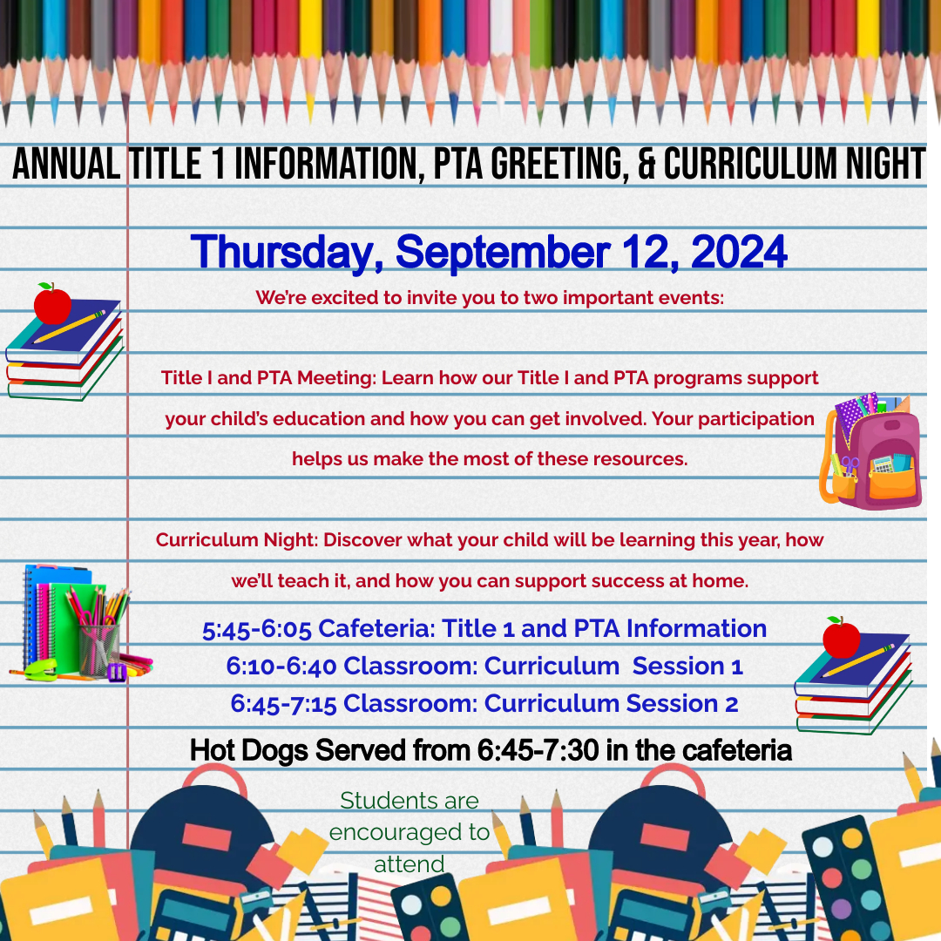

**-------------------------------------------------------------------------Please fill in the information below and return to your child’s teacher by August 30, 2024.**

**Student Name: ____________________ Teacher Name: ____________________**

**Will you be attending the event?** Yes No

**How many people will be attending (including yourself)?** 1 2 3 4

More (Please specify): [_________________________]